Create Node Red Service

|  |  |
| --- | --- |
| Date | 17 November 2022 |
| Team ID | PNT2022TMID24184 |
| Project Name | Personal assistance for seniors who are  self reliant |

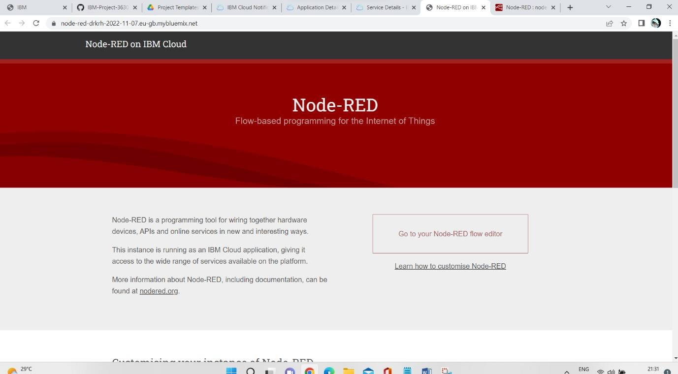

Node-Red

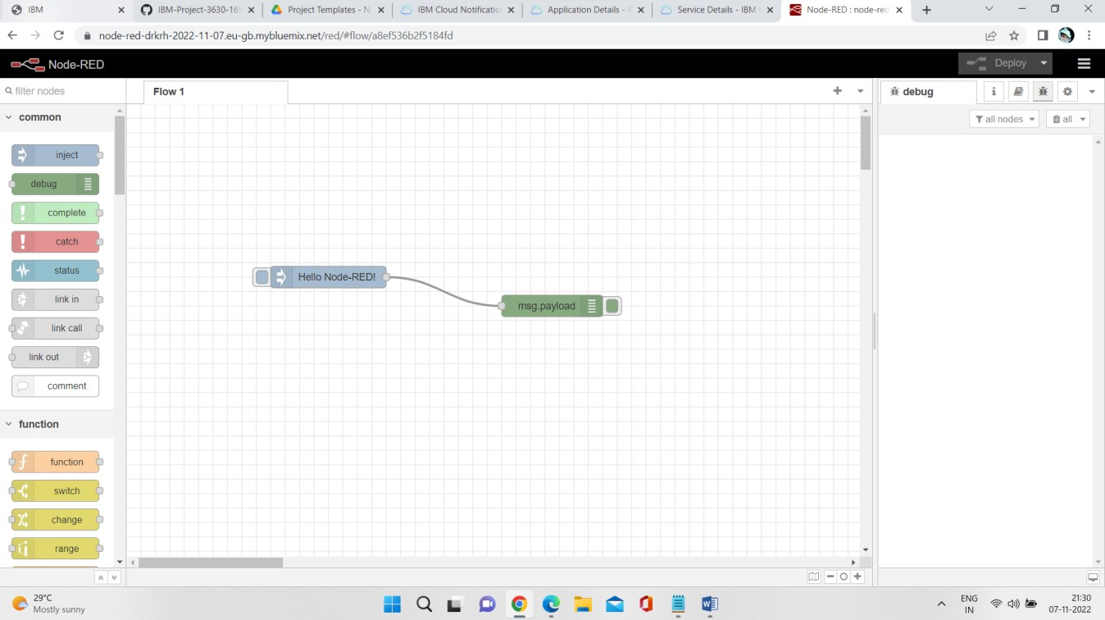

Successfully Node -Red Installed….!